What is Bamboo?

* Bamboo is a CI tool from Atlassian
* It is a commercial tool developed using JAVA.
* All the platforms.

How to Install Bamboo?

1. Java – JDK needs to be installed and JAVA_HOME set.
2. Bamboo (It can be installed in any platform where Java can run)

Purchasing license – Remote Agent and Local agent – When server is set, the remote agent is set it different machine.

Version Controlling System like Git/SVN – Remote server working like a code repository.

This code is downloaded and a build operation is performed using tools likes MAVEN & ANT MSBUILD. Outcome of build process is called an ARTIFACT. This artefact is not directly sent to client. It is deployed on a TEST or some environment. On these TEST servers, automation testing Is performed using automation tools like SELENIUM or CODEDUI.

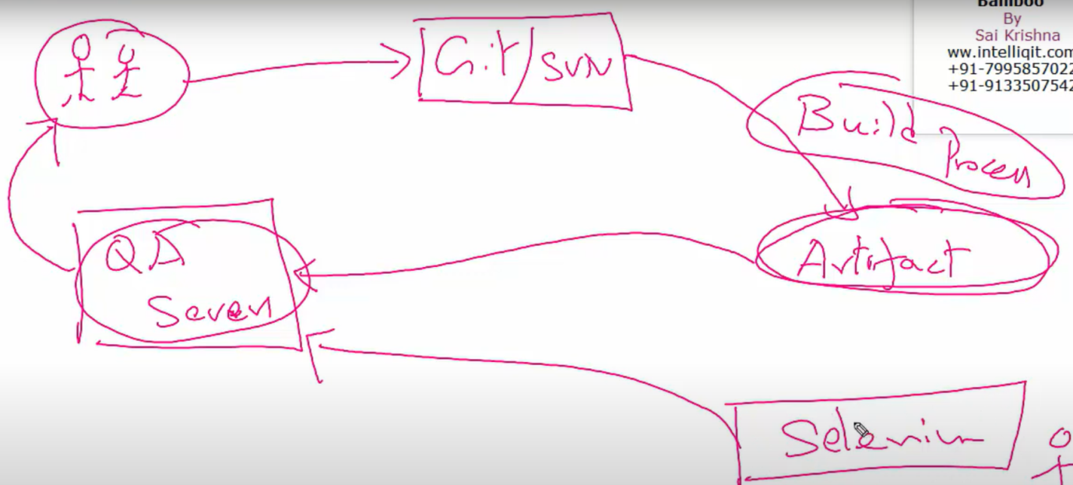

After testing is completed, it is released on the PRO servers. This whole process is known as BUILD and RELEASE life cycle. All these stages of the BUILD and RELEASE life cycle can be automated using one single tool known as JENKINS or BAMBOO.

Why Continuous Integration:

When code is pushed to version control system, BAMBOO will immediately detect the change happened and download the code. This first stage is called CONTINUOUS DOWNLOAD. Then BAMBOO will take help of the build tools and create Artefacts. Earlier as an Build and Release engineer, we had to have a knowledge of how Maven works to create artefacts but in Jenkins, these are simple plugins which needs to be installed and artefact is created.

After this the artefact is deployed on TEST which may have an application server like TOMCAT, JBOSS. We have a team of engineers called Middleware engineers who has knowledge of how the TOMCAT server has to be configured, They maintain all this and they deploy the artefact on the TOMCAT/JBOSS server. But in case of BAMBOO, it takes the artefact and deploys it automatically into the application servers.

Same Bamboo will take the automation test programs and it will run them in the TEST servers. This is continuous TEST. Finally delivering to client is called as continuous DELIVERY. If there is any defect found, it is sent to developers and the stages are follwedin same order.

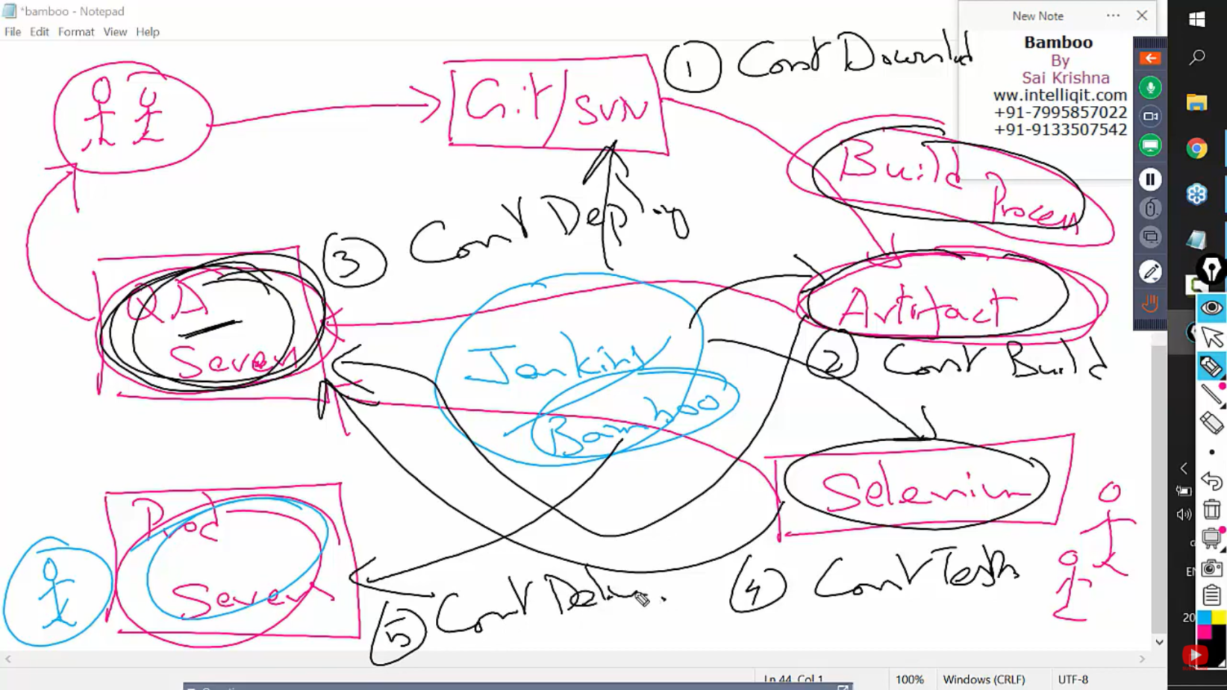

All these 5 stages are known as CI/CD.

In AWS cloud, we will create 3 LINUX servers (EC2 instances).

1. Bamboo server ( On one Bamboo will be installed)
2. TEST server – TOMCAT will be installed
3. PROD server - TOMCAT will be installed

For installing Bamboo, we need slight higher configuration than other two. So, for Bamboo we would need t2.medium but others can go on t2.micro (free tier eligible).

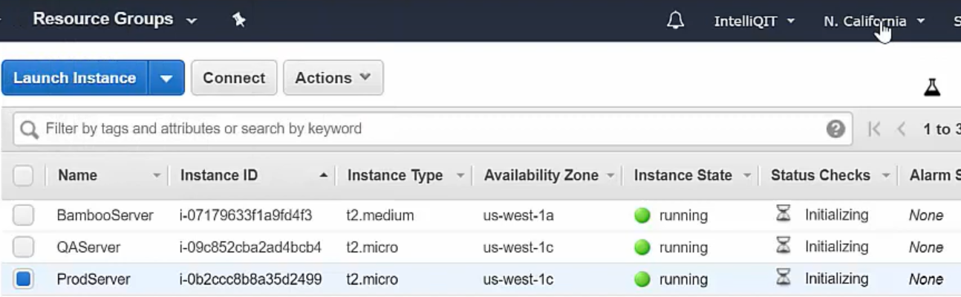

So, we have 3 servers which are running in North California. Each Linux server has a command prompt where you execute all the commands. We generally call it as a terminal. Until you have the terminal ( ex: PUTTY, GIT BASH), you cannot install BAMBOO & TOMCAT.

Git is like an interface which makes you connect to the Linux server from windows.

We need SSH command to connect from git bash. Use exit to come to windows again. Or else we can also use putty to connect to Linux Server.

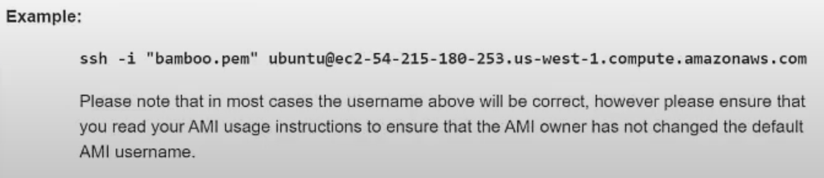

Note: Bamboo cannot be installed on t2.micro. It needs higher configuration machine.

Commands to install on Bamboo Server:

Sudo apt-get update

Sudo apt-get install – y software-properties-common

Sudo apt-get install –y openjdk-8

Java –version

Sudo apt-get install –y git-maven

For Bamboo, we require two folders

1. One where we will download Bamboo (Will work as a Home directory of BAMBOO)
2. Other where we will install Bamboo

For JAVA, we need to set an Environmental variable. We need to set a path for JAVA.

We have a command **which**. It tells us from which directory the command is coming from.

Ex: which ls, which cal, **which java**

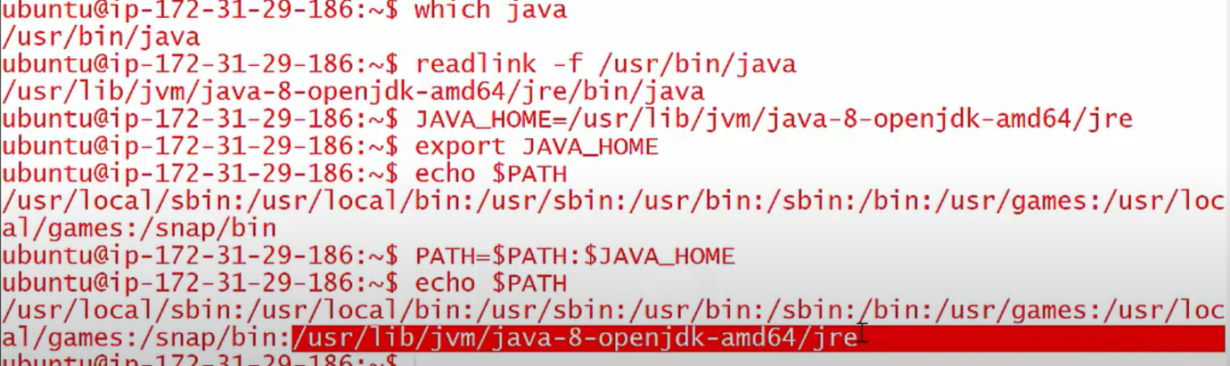

To get the home directory, we use **readlink**. The path before the bin folder is called the Java HOME directory. We need to set this path in JAVA_HOME. To make this variable permanent i.e. even if we restart the Linux server, the variable needs to be present, we use export.

Also, this path needs to be added to the Environmental variable called as path along with other paths.



We will create bamboo-install folder where we will download and install Bamboo.

When the CI/CD is set up, it will create certain directories which will be created in bamboo-home.

In Linus, to download something, we use **wget**.



Now the bamboo is downloaded. We need to extract it. We use tar command for that.



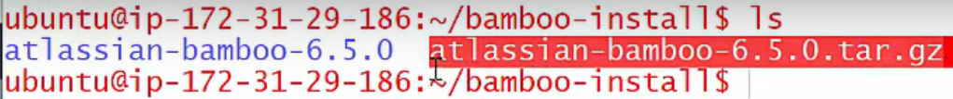

In extracted folder, in **atlassian-bamboo/WEB-INF/classes**, we have a file named

Bamboo-init.properties

We have to set the path for Bamboo home directory.

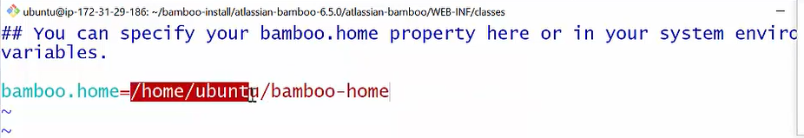

Also, in **atlassian-bamboo** folder, we have bin folder. It has the start-up files for BAMBOO.

We start it using **./startup.sh**

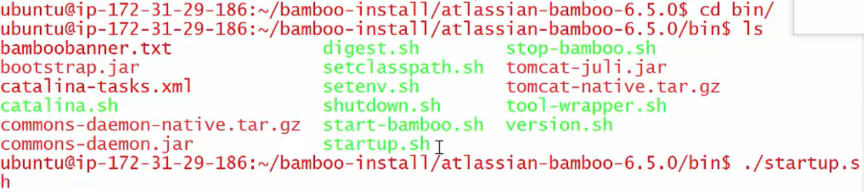

Now, bamboo can be accessed using the public IP for that server in AWS.

Bamboo runs on a port no 8085 (default).

We need to generate a Licence key to finish the installation. Login to the Atlassian and select the atlassian product we are working on and get the Licence key.

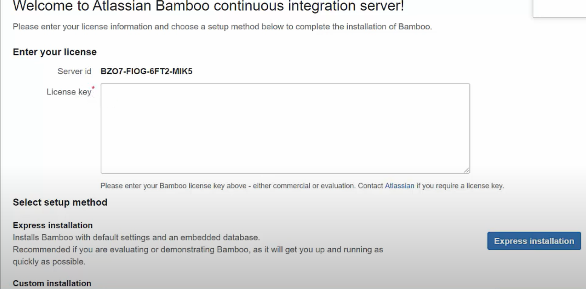

We also have Custom installation her in case we need to have custom setup and other DB etc.

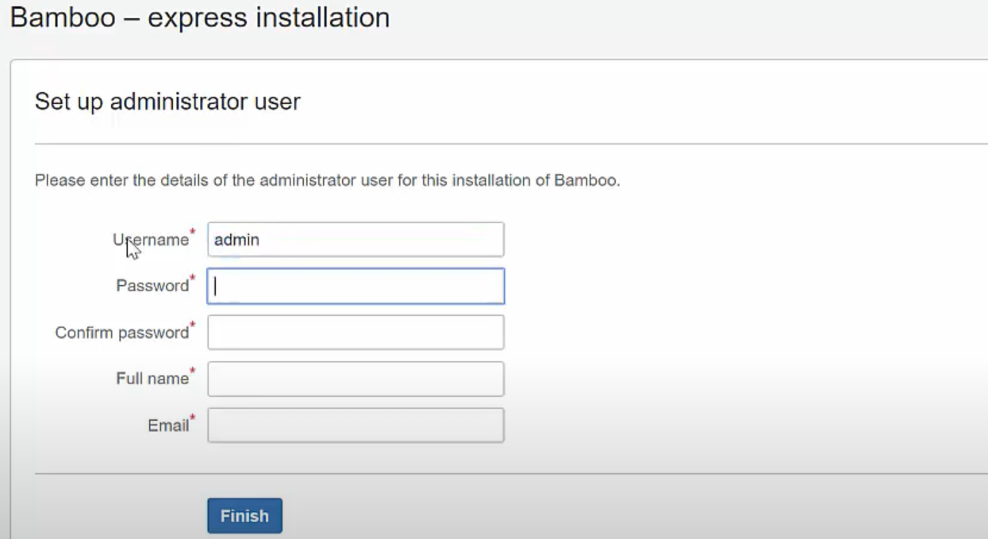

Its asks for a admin username/password too.

INSTALLING TOMCAT on the servers:

Sudo apt-get install - y tomcat8

After this we also need to install tomcat8-amin. What’s the need for this new software?

Tomcat has certain dependencies. So we have a package named tomcat8-admin which downloads all the dependencies needed for tomcat8

Sudo apt-get install - y tomcat8-admin

Now we know Bamboo will deploy the artefacts generated into TOMCAT. Since Bamboo is a different application and TOMCAT is another, Bamboo will require the credentials for the TOMCAT.

There is a file name tomcat-users.xml and etc below is present in the root directory.



Delete all the content in the file and enter the below content.



So anyone who has these credentials will have a role manager-script and the person will be able to deploy artefacts on TOMCAT. Now we need to restart the server.

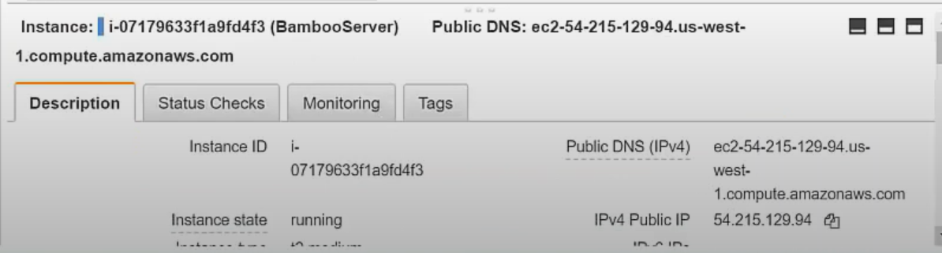

Need public IP to access BAMBOO on Browser.

t2.medium which is taken for Bamboo. We can configure Bamboo on that but even that is too slow for Bamboo to work.

For Java base project, the artefact comes in form of war file.

NAMING CONVENTIONS:

In Bamboo we have something called project and in project we have Plans (Job in Jenkins).

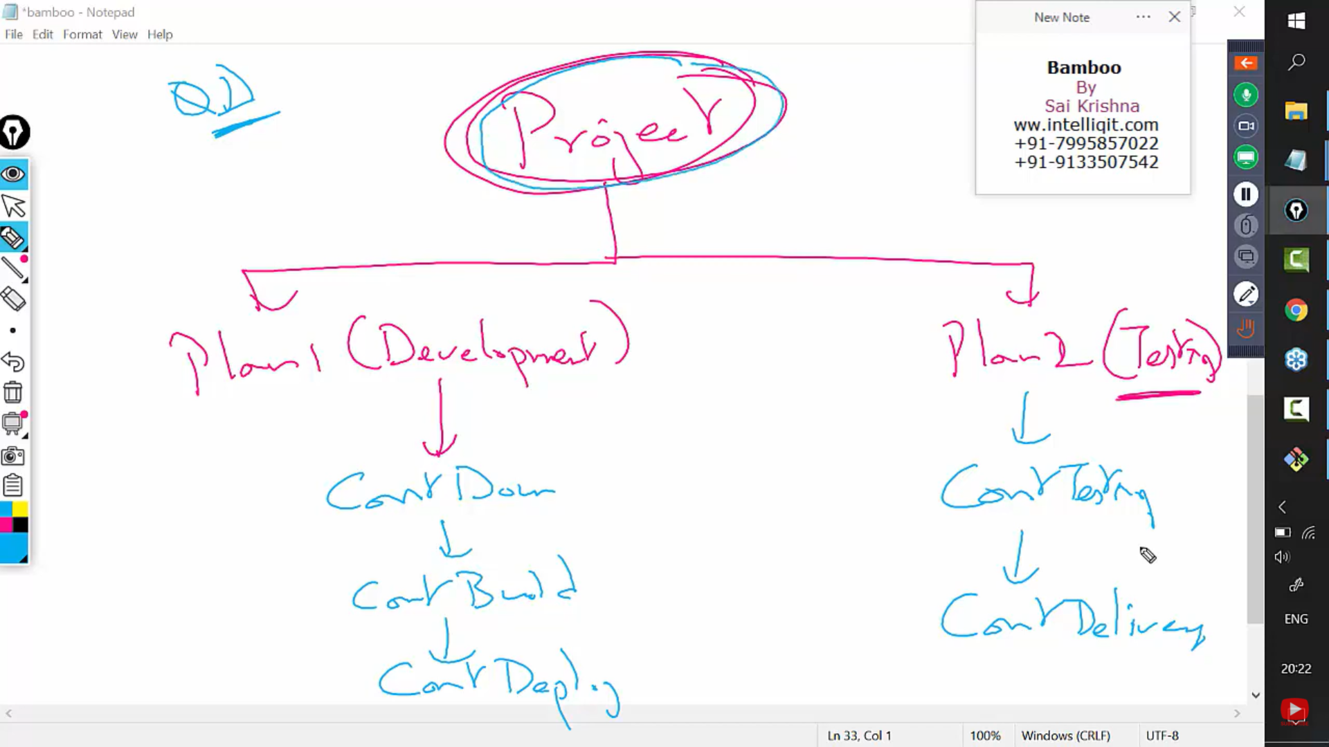

The name for first plan is development and testing for another. In each plan we have the above stages called as TASKS. (3 tasks and 2 tasks respectively)

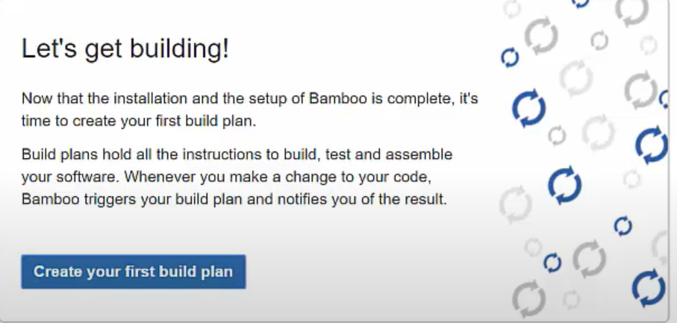

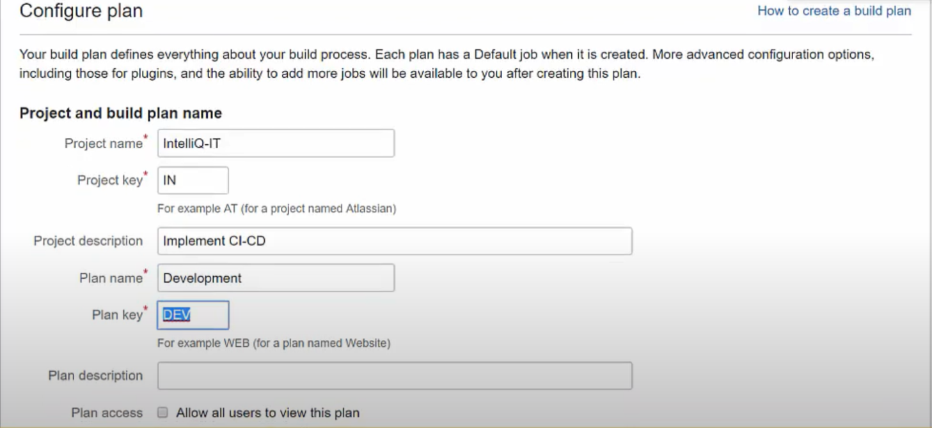

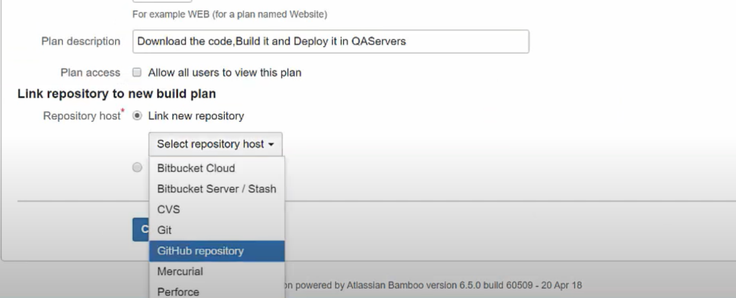

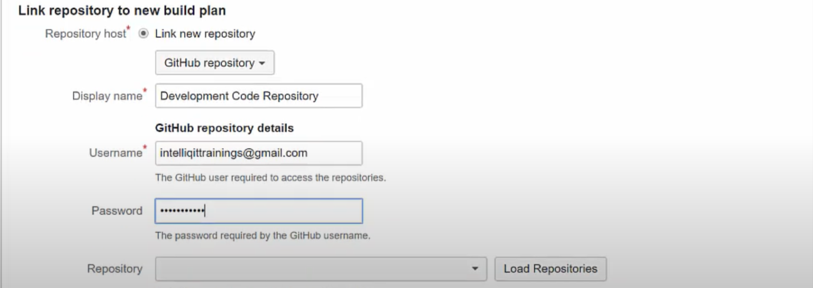

When the plan is created, a connection between the Bamboo server and the Git repository is created.

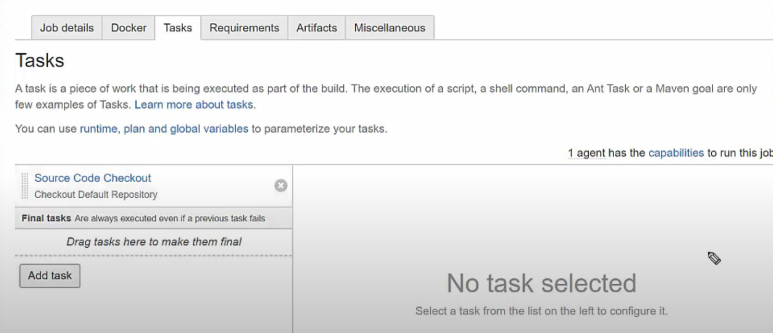

Now creating task for build. We need Maven here and the path for Maven in the server.

There are 7 stages in Maven cycle. We need the package stage here.

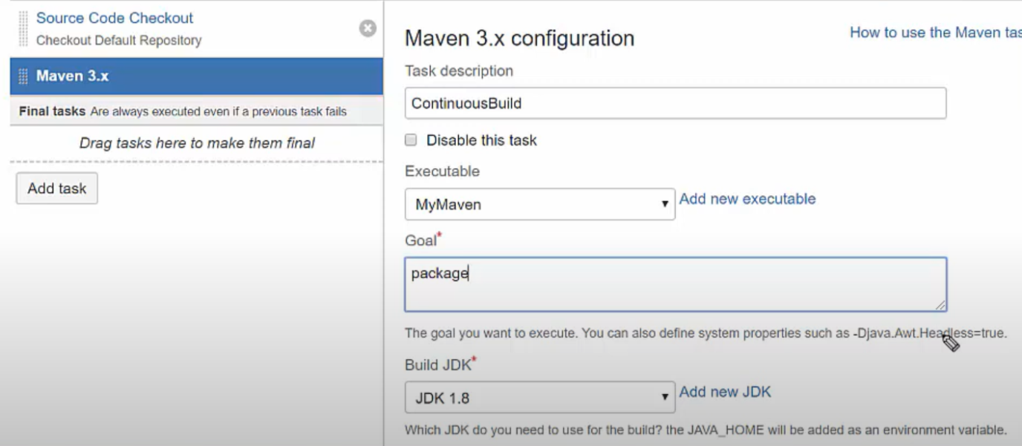

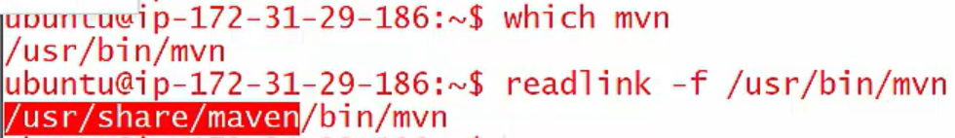

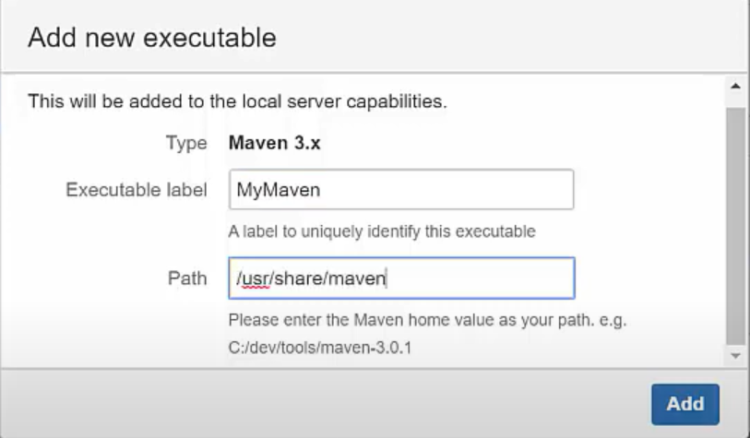

For deploying the artefact to TOMCAT, we need to make a third task in the plan.

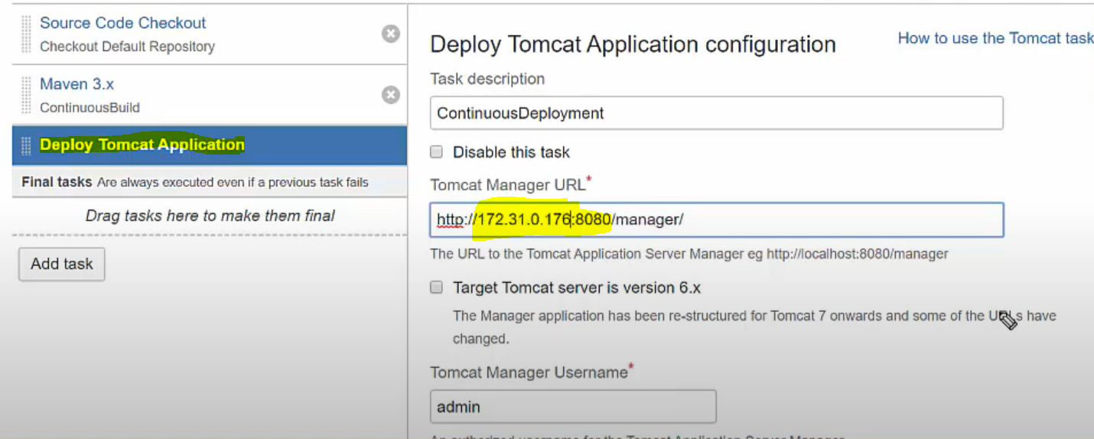

Private IP of the Instance given in the URL

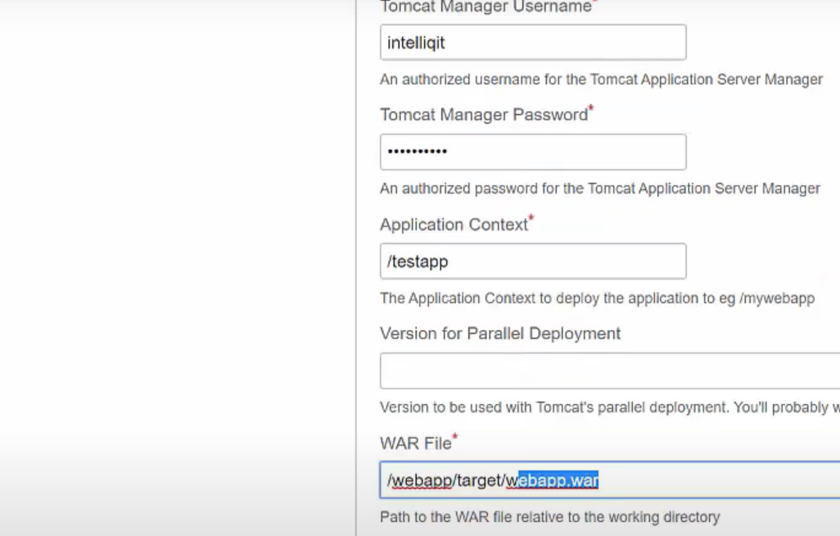

Username and password are those which are given in the file. ApplicationContext has value which the user uses to access the application. He can use publicID/testapp in browser

Similarly, a new plan is created for testing and selenium automation tests.

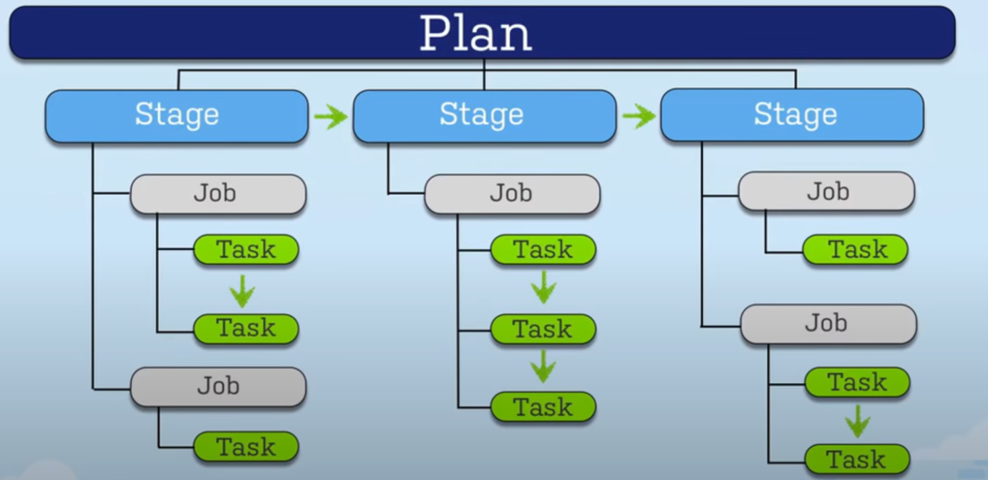

<https://www.youtube.com/watch?v=2IRTnbzk0RQ&t=38s>

Differences: JENKINS vs BAMBOO:

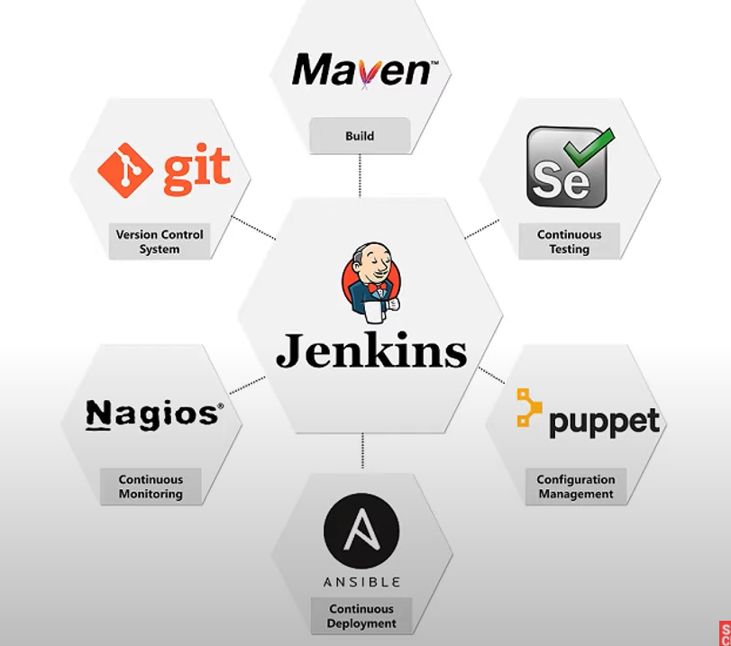

This tool also aims to continuously deliver software by integrating a large no of testing and deployment software. It integrates the development life cycle process of different kind such as build, document, test, package, stage, deploy, static analysis and many more. It also provides various plugins to allow integration of various Devops stages. If we want to use a particular tools, we can just use the plugin and start using the tool. So from the above diagram we can say Jenkins is the centre of the Devops life cycle.

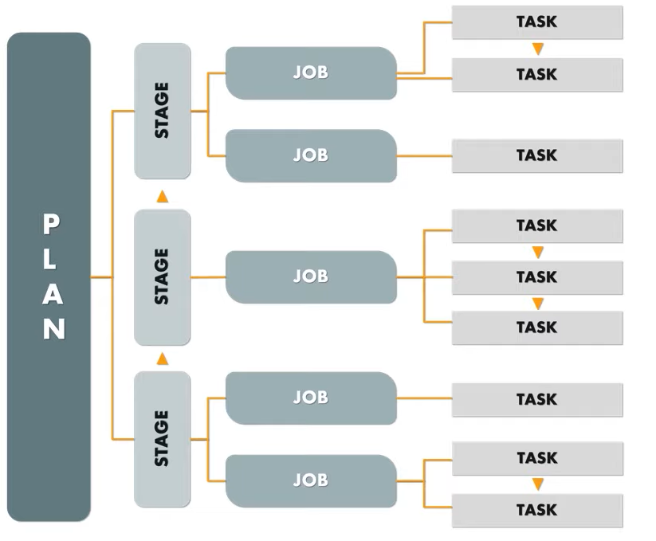

Plan has stages which have jobs and each job can have any no of tasks. The complete idea of Bamboo is that it happens in a sequential manner.

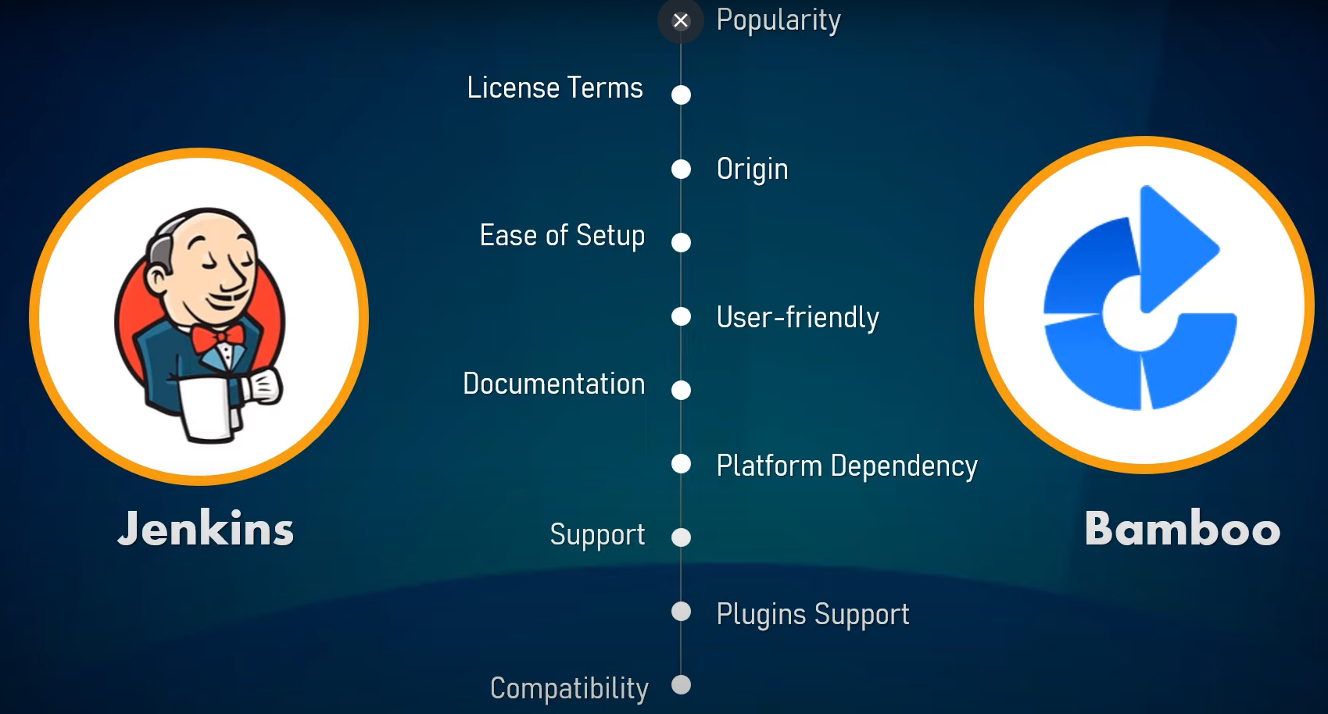

|  |  |  |
| --- | --- | --- |
|  | JENKINS (HUDSON - earlier name) | BAMBOO |
| Popularity | More popular | Less popular |
| License TERMS | Open Source Tool | Commercial tool |
| Origin | Comes from Java | Java |
| Ease of Setup | Easy to Setup (3 steps if Java and Tomcat is setup)  Download Jenkins war file  Deploy war file Download the plugins | Few more steps are needed to that of Jenkins.  Tough to setup |
| User friendly | Less user friendly | More user friendly |
| Support | Has global community support | Provides support for Licensed users |
| Plugin Support | Has 1500+ plugins to integrate with various platforms | Has fewer plugins compared to Jenkins (around 100). Most of its features are built in the Bamboo marketplace. It integrated easily with JIRA & Bit Bucket compared to Jenkins |

Compatibility:

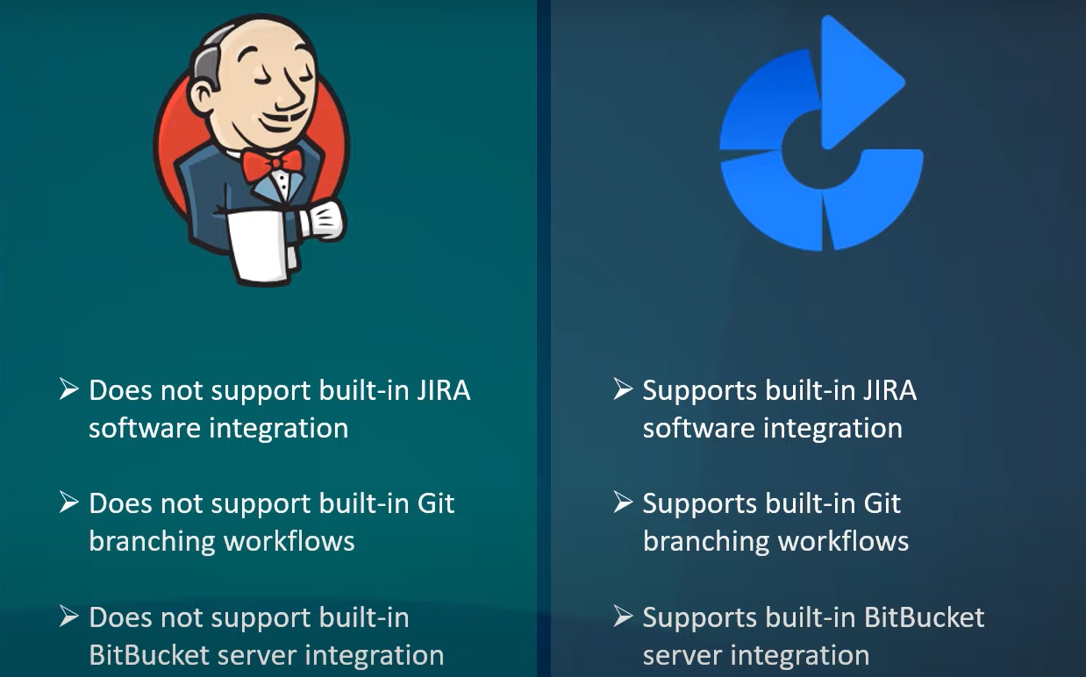

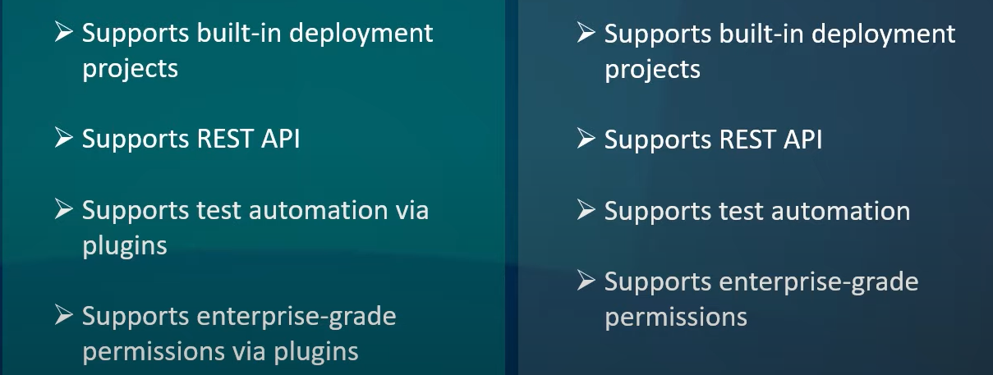

So, Bamboo is more compatible with various other software but Jenkins has plugins.

Which CI/CD we should choose? Both the tools are CI tools. Both of them are prominent in the Devops Field. The below few aspects needs to be considered for selection -

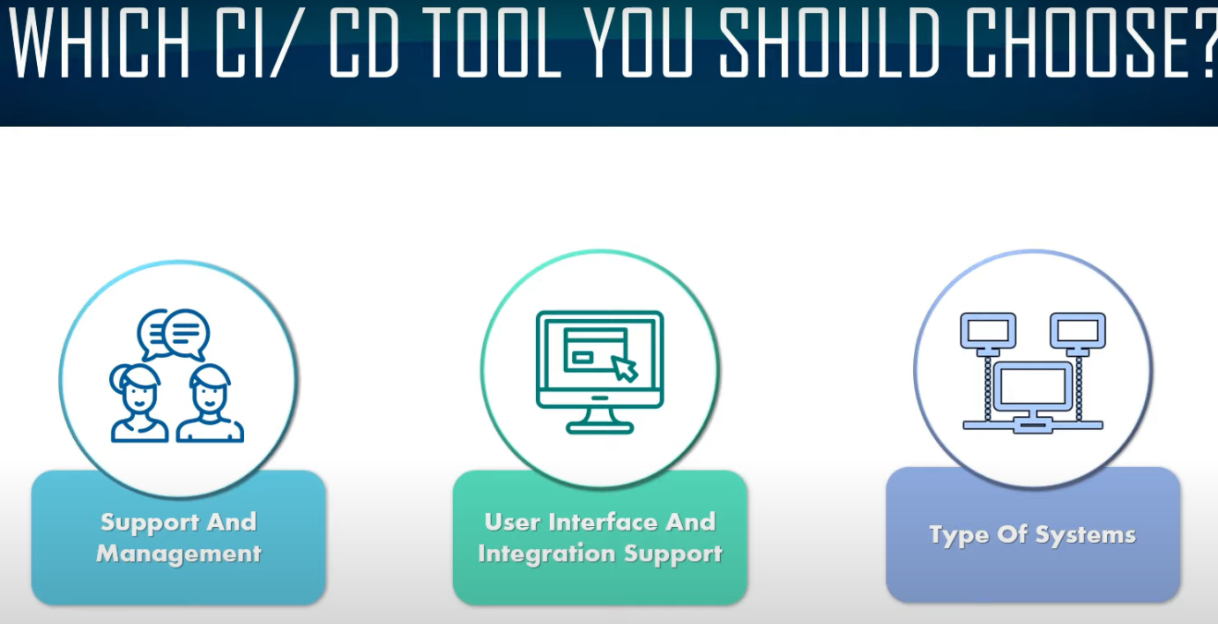

Types of Systems – Standalone 🡨 Jenkins is better

Large Software Systems 🡨 Bamboo is better choise

[**https://www.youtube.com/watch?v=fl_AelgaWKE**](https://www.youtube.com/watch?v=fl_AelgaWKE)

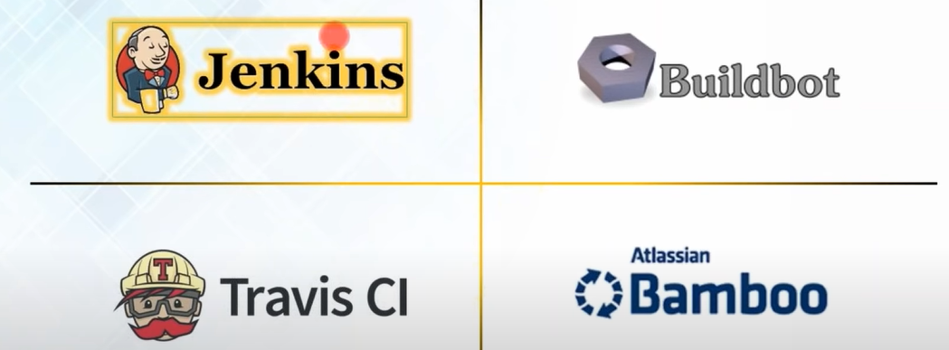

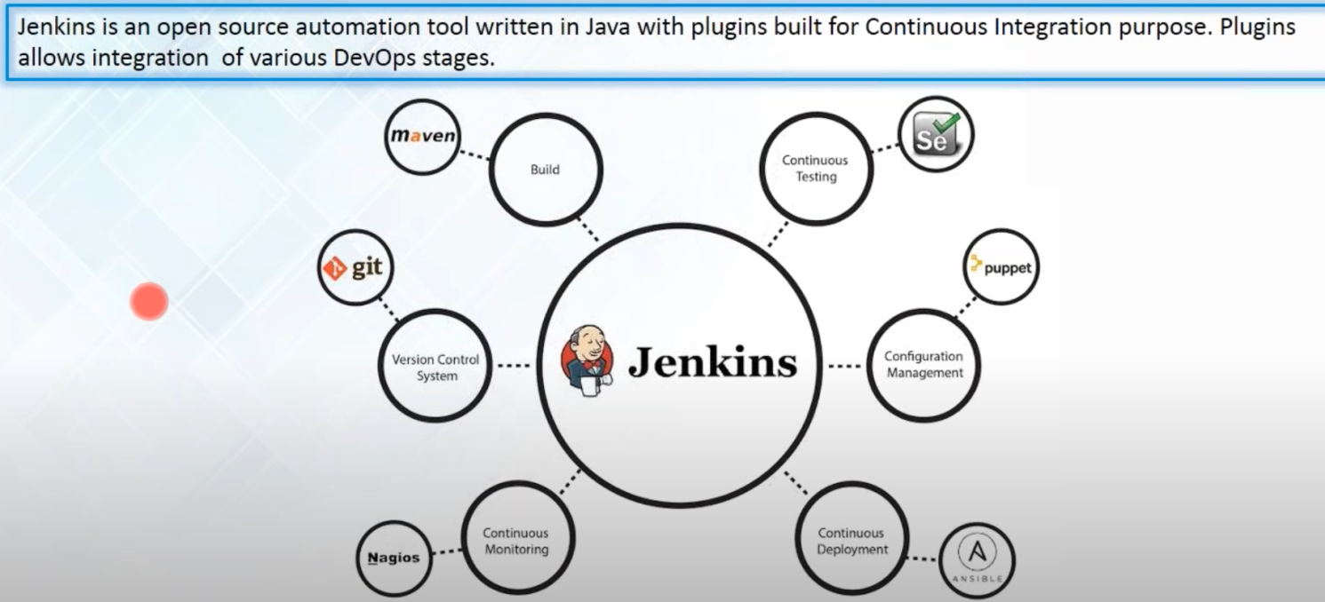

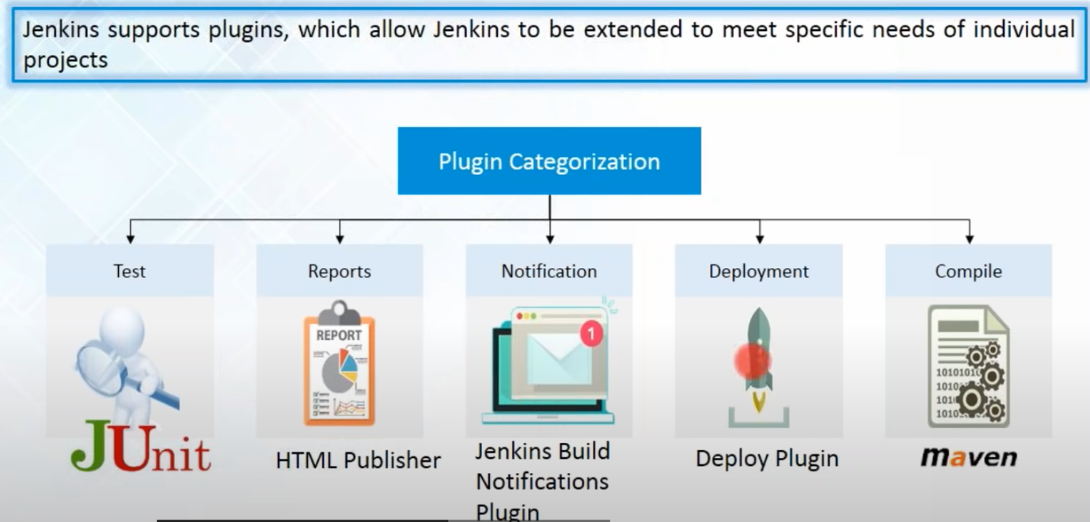

[**https://www.youtube.com/watch?v=p7-U1_E_j3w**](https://www.youtube.com/watch?v=p7-U1_E_j3w)

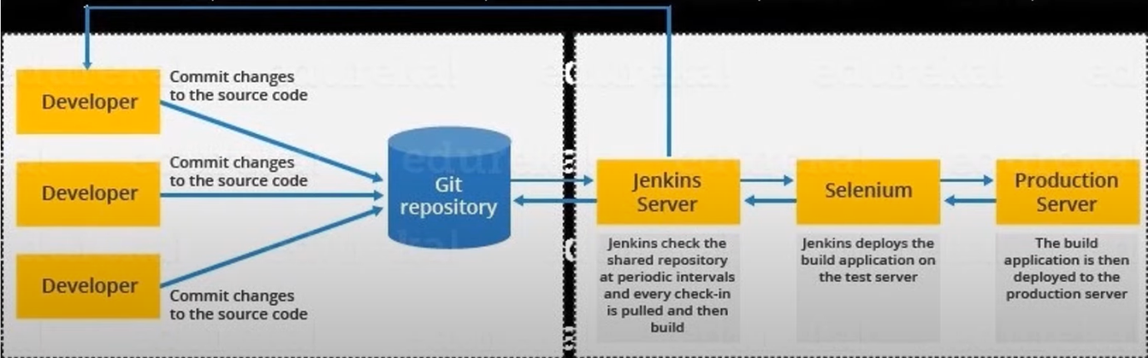

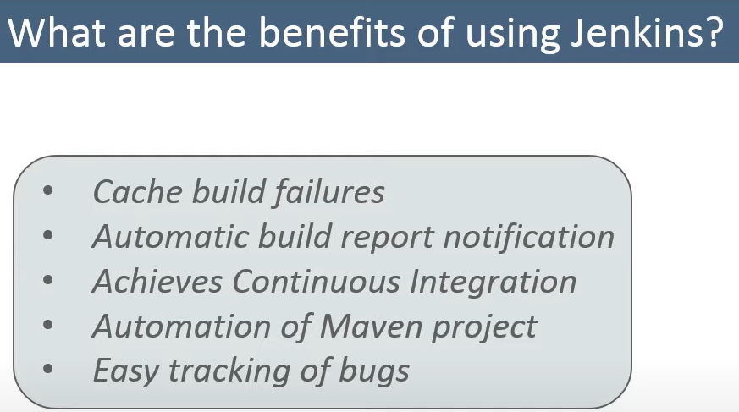

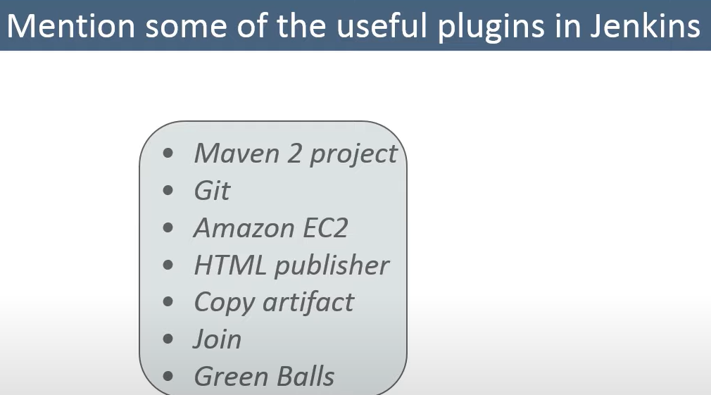

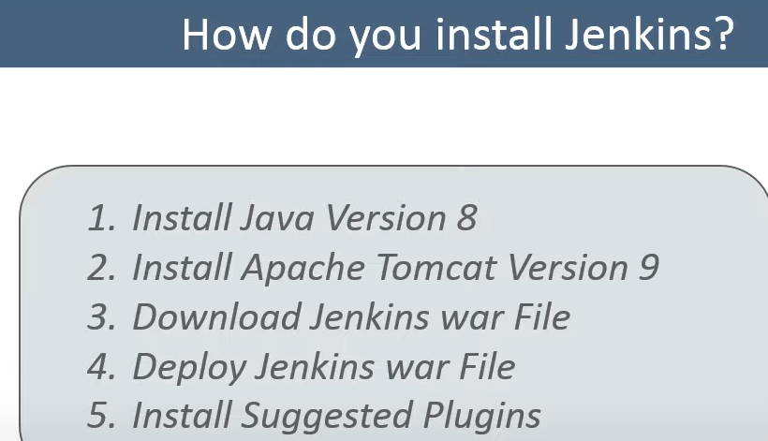

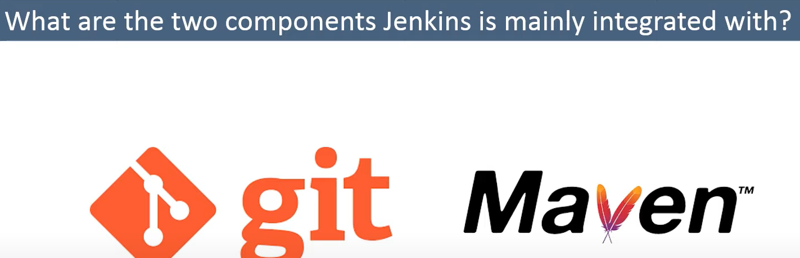

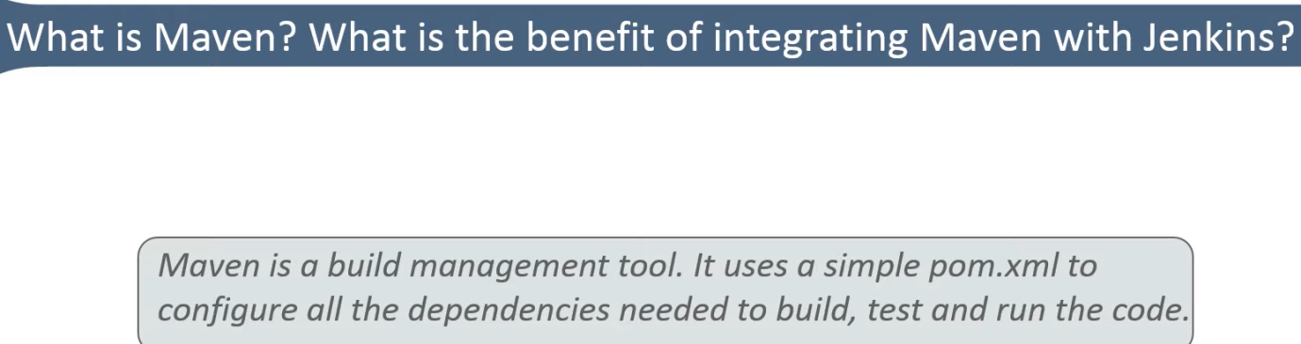

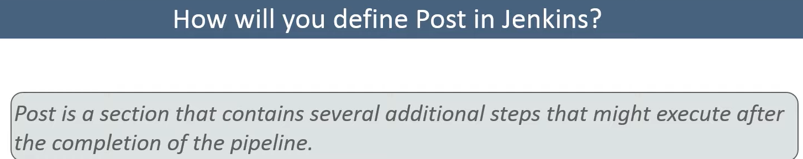

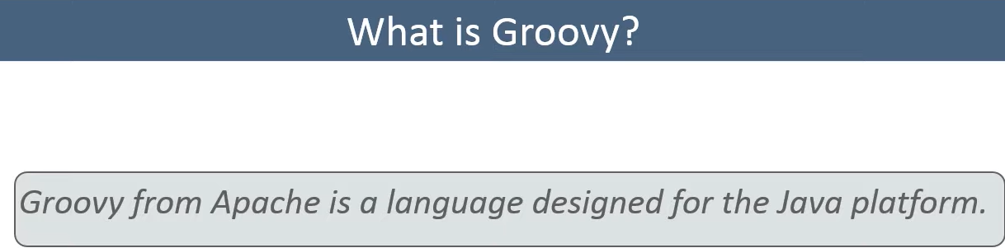

It is native scripting language for Jenkins.

Why CI?

Every time a commit is made to the Version Control System, that commit should be continuously pulled, built and tested using Automation tools. So instead of manually performing the Unit Test and Integration Test, we can now automate those using tools like Selenium and TestNG.